A000-Bactria-Cylinder Seal-Running Figures-5 x 2.3 c m



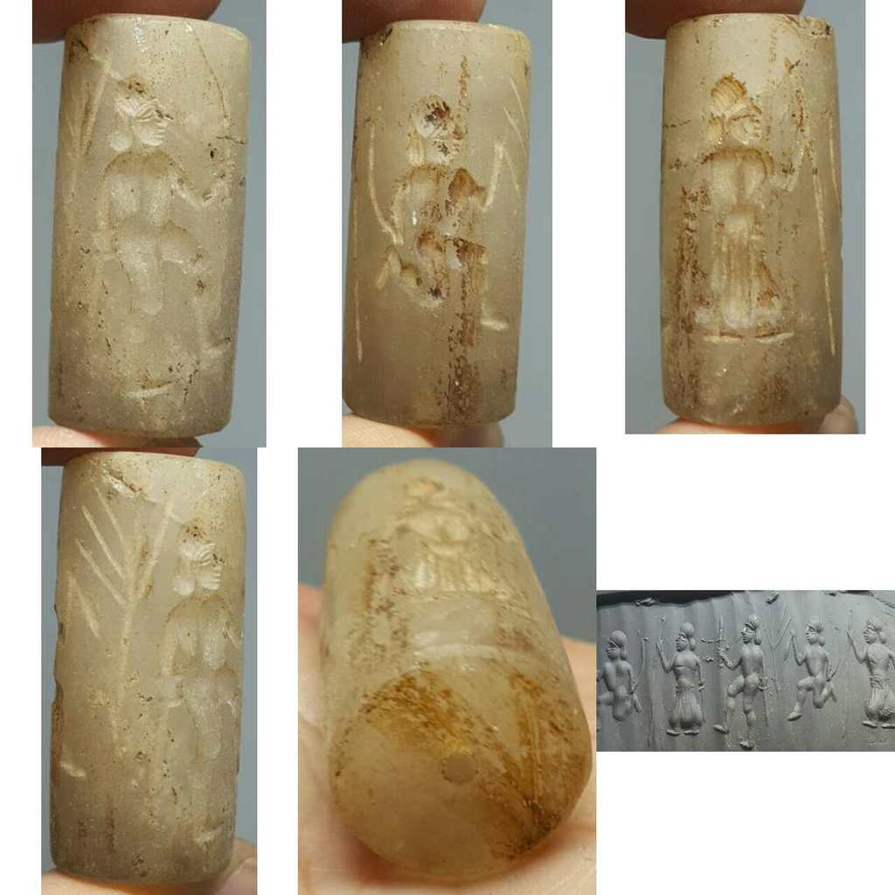

Sold by [vintage.intaglio](http://myworld.ebay.com/vintage.intaglio) ( [457](http://feedback.ebay.com/ws/eBayISAPI.dll?ViewFeedback&userid=vintage.intaglio) )

Estimated delivery Friday, Dec 23, 2016 - Tuesday, Jan 10, 2017

#### [Old Wonderful Crystal intaglio Stone Near Eastern BEAD # L](http://www.ebay.com/itm/282282020474)

|  |  |
| --- | --- |
| Item price | $20.50 |
| Quantity | 1 |
| Item number | 282282020474 |
| Shipping service | Economy Shipping from outside US |

## Shipping address

Ralph J Coffman Jr

149 Atlantic Ave

Swampscott MA 01907-2427

United States

## Order total

|  |  |
| --- | --- |
| Subtotal | $111.50 |
| Shipping | $11.00 |
| Discount | -$6.00 |

**Total**

$116.50